**DTSX Parser Tool User Manual**

**Prerequisites**

**Operating System** : Windows 10 or above

**Tools** : Microsoft Excel (Office 365) – To view output file

**Software Installation Steps**

* To run the DTSX Parser tool,
* We need to install below software upfront to make sure the tool is running properly.

Step 1:

Open the “**Software to Install”** folder and download & install the **Visual studio installer** software (vs_community__27f0918bd06547c6ae5e1ca1dda846ab.exe) file in your system.

* Please follow the on-screen instructions and complete the installation steps.
* Once installed, please cross check the installation status.
* Click windows start button and search as below,

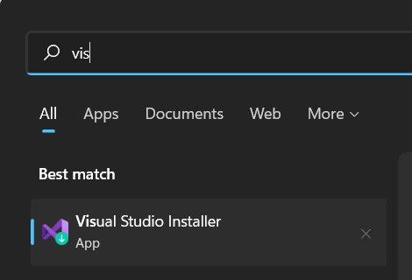

Step 2:

**2.1** Open **Visual studio installer** and go to **Workloads section**, check **ASP.NET and web development** package under **Web & Cloud**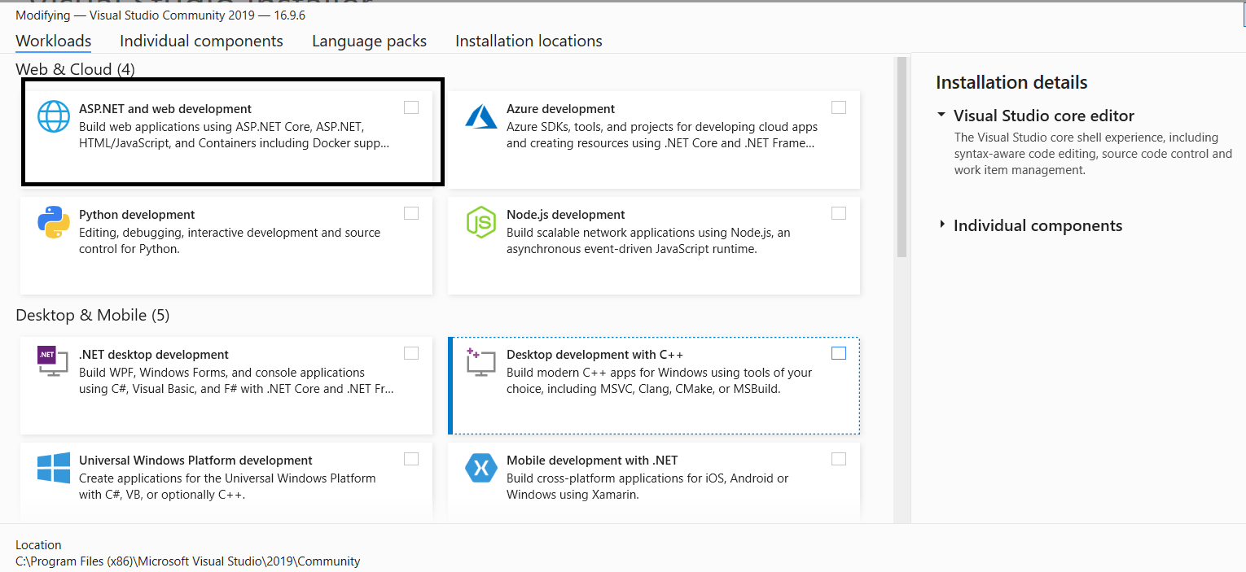

Please ensure **.NET Framework 4.7.2** development tools selected under Installation details

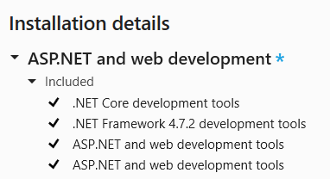

**2.2** Scroll down below and under **other toolsets section**, please check **Data storage and processing** package, please ensure **SQL Server Data Tools** option selected under Installation detail Click install option in the right-side bottom corner to proceed with the installation.

Click install option in the right-side bottom corner to proceed with the installation.

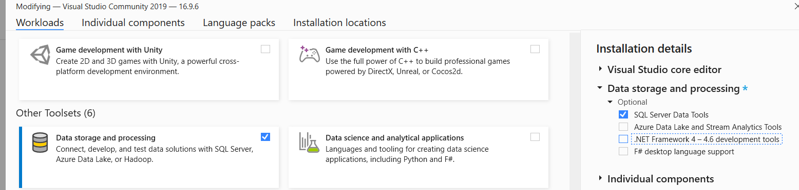

**2.3** Please wait for 10-20 mins to download and install the packages and the visual studio will be installed in the system.

Step 3:

Open the “**Software to Install”** folder and install the **Data Tools installer** software (Microsoft.DataTools.IntegrationServices.exe) file in your system.

Please follow the on-screen instructions and complete the installation steps.

Tool Execution Steps

STEP 1:

1. Download and extract the file: **DataFlow.DTSXParser.zip**
2. Please open the folder and go to **ParserInput** **folder** and look for **parserInput.txt**

The Purpose of this file is to get the DTSX file name along with file path and these will be passed into the main method to invoke the execution.

**To Pass a Single DTSX package:**

**To Pass Multiple DTSX packages:**

STEP 2:

Open the **bin\Debug** folder under the **DTSX Parser Tool** and double click the **Dataflow. DTSXParser** application exe and a command prompt will pop out and DTSX file will be converted into an Excel file.

STEP 3:

Open the FinalOutput folder under the DTSX Parser Tool to see the generated excel file.

Excel Output file

